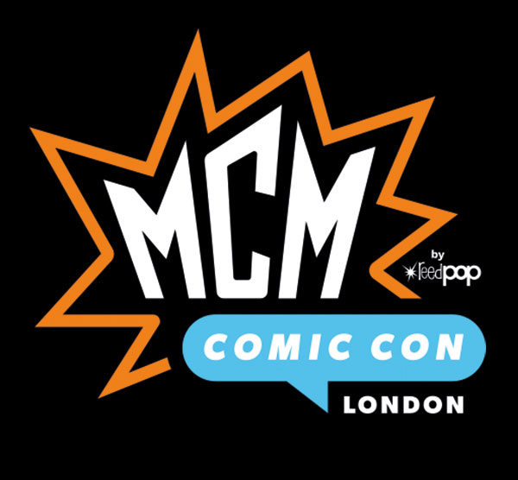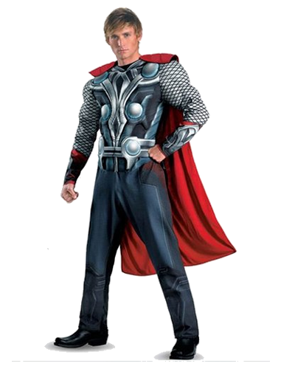

**Leading fancy dress costume designers**

**Fancy That will be attending MCM Comic Con,**

**London October 2019.**

**Fancy That are using the up-and-coming exhibition to attract new customers who are fans of the show by showcasing past and current costume designs they have created for leading manufacturers around the UK.**

**@FancyThat**

**@FancyThat**

**Fancy That - fancythat@sky.com** **- 01932 797701**